useMemo is a built-in react hook, that can potentially make your app more performant, by managing unnecessary re-rendering.

App.js
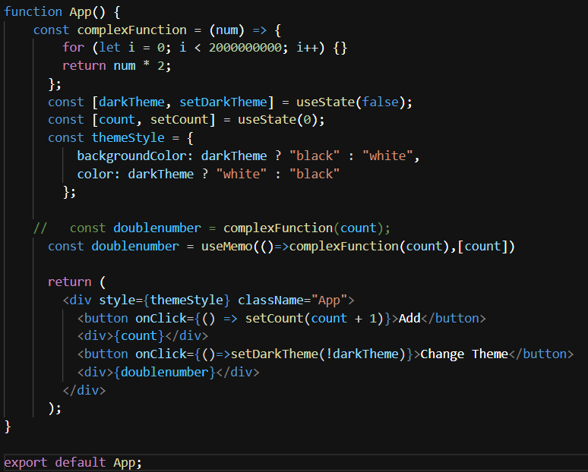

Here just comment and uncomment the doublenumber variable you can see the difference
Overusing of useMemo hook can also slow down our application because useMemo uses caching technique and this technique consumes memory

